***Practical 1***

**AIM: Hello World Example, finding errors present in the program, Insert Comments in Program, PHP Variable Example, Global and locally-scoped variables – Example, Constant string Example, PHP Example to calculate the area of the circle, PHP Example to calculate the area of the triangle, PHP Example to calculate the area of the square, PHP Example to calculate the area of the rectangle.**

* **Directory**

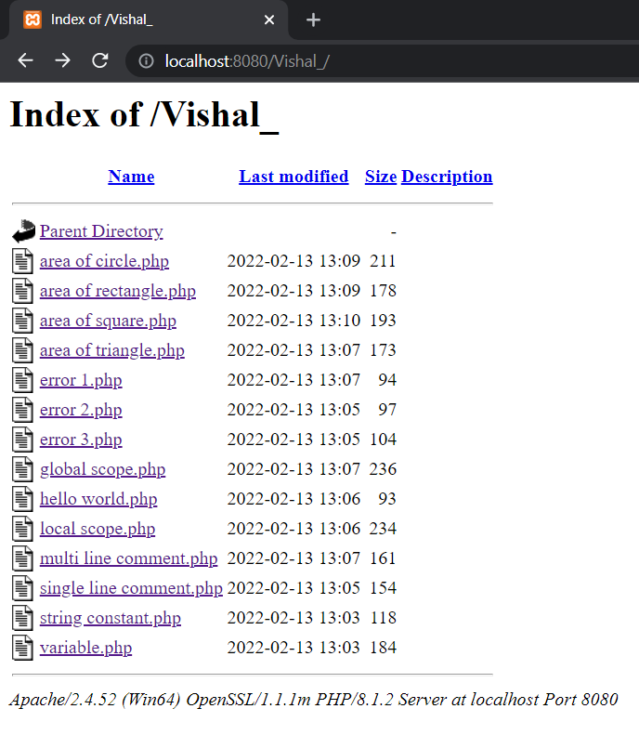

1. **Hello World!**

Input

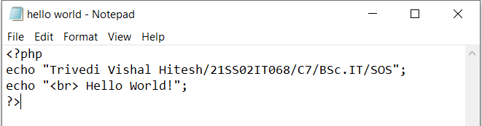

Output

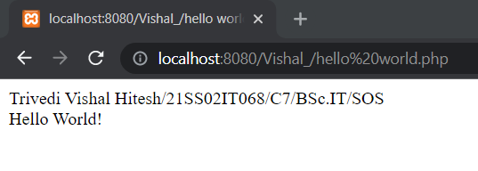

1. **Error 1**

Input

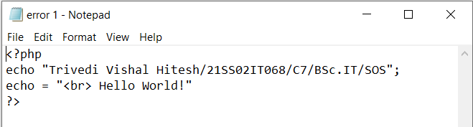

Output

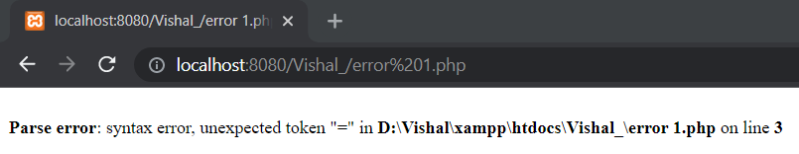

1. **Error 2**

Input

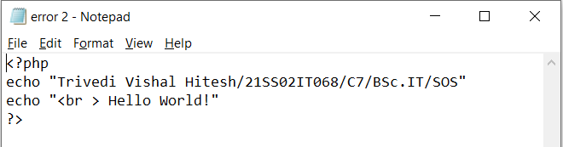

Output

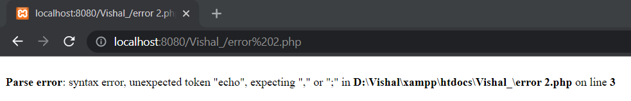

1. **Error 3**

Input

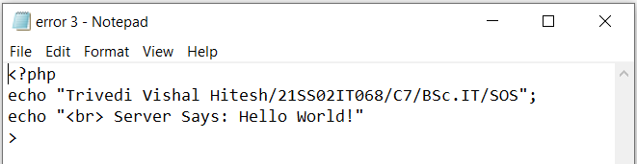

Output

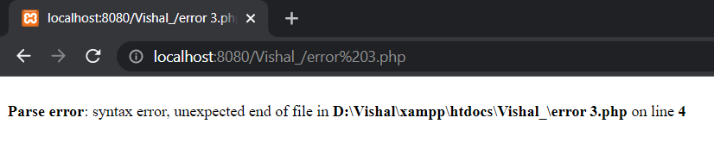

1. **Single Line Comment**

Input

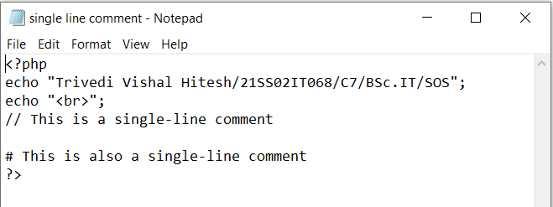

Output

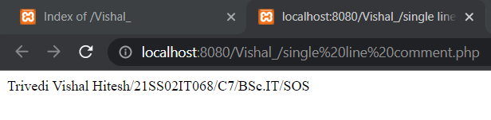

1. **Multi Line Comment**

Input

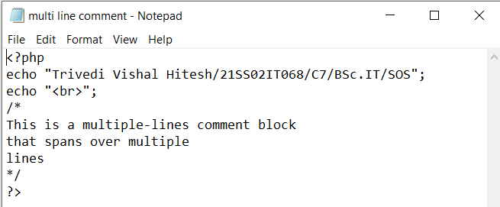

Output

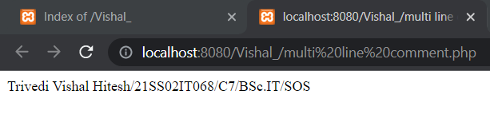

1. **Variable**

Input

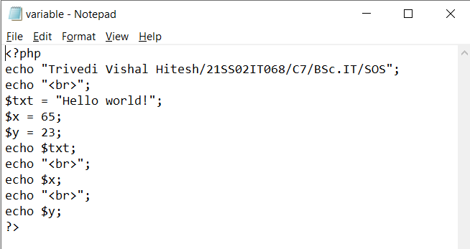

Output

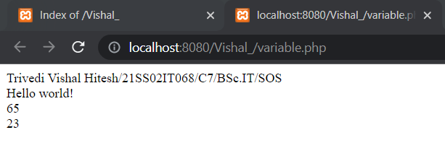

1. **Global Scope Variable**

Input

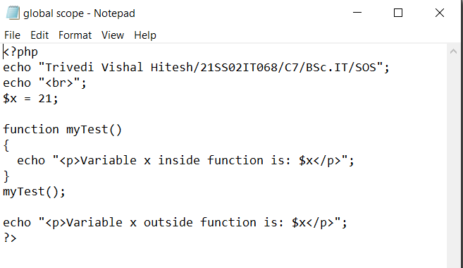

Output

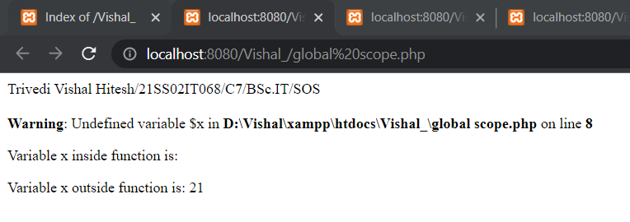

1. **Local Scope Variable**

Input

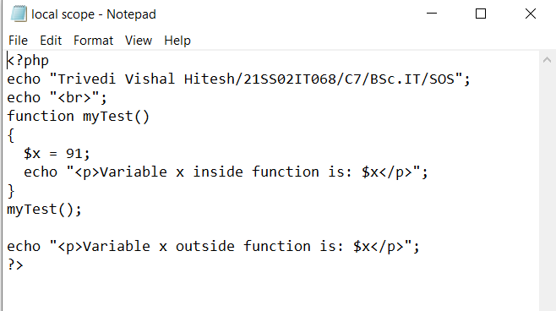

Output

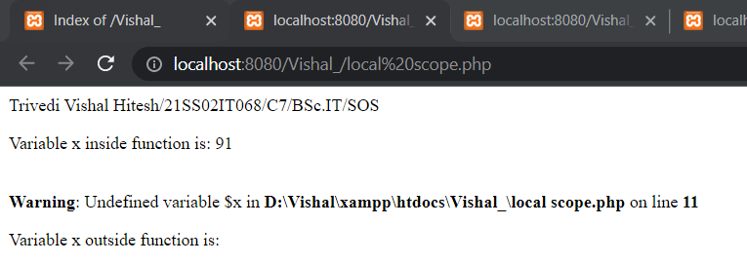

1. **String Constant**

Input

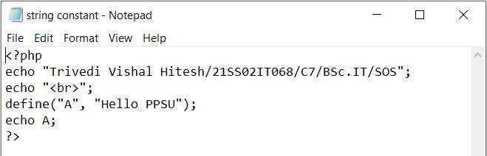

Output

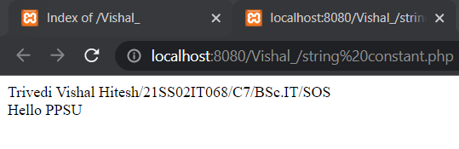

1. **Area of Triangle**

Input

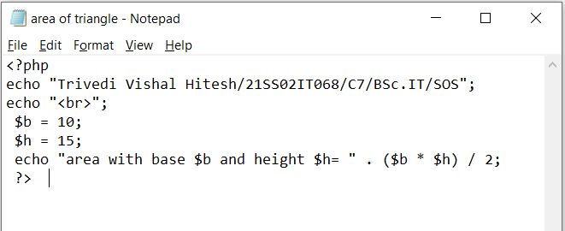

Output

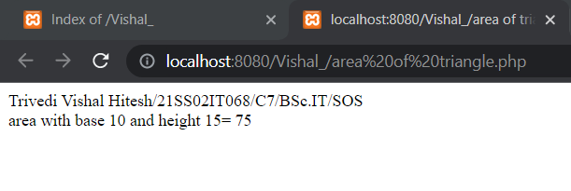

1. **Area of Circle**

Input

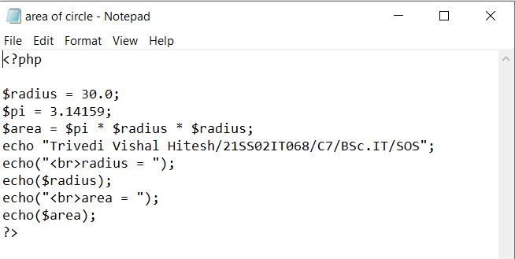

Output

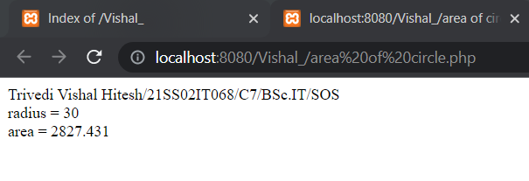

1. **Area of Square**

Input

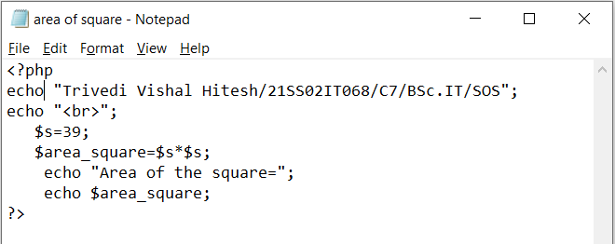

Output

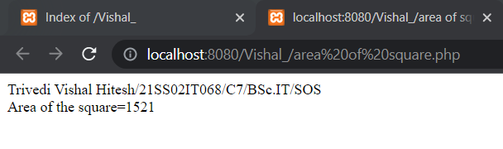

1. **Area of Rectangle**

Input

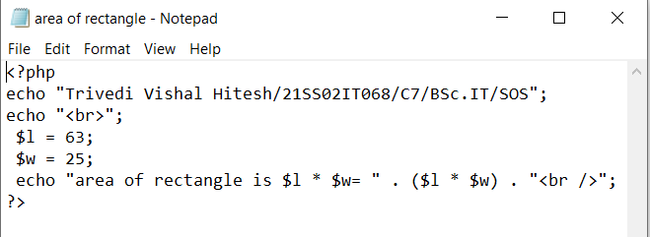

Output

